Mission 360

2 Corinthians 9:10

Now He who supplies seed to the sower and bread for food will supply and multiply your seed for sowing and increase the harvest of your righteousness;
Mission 360 is a project focused on enabling the spiritual impact of Grindstone Lake Bible Camp to continue into the future. For over 80 years this camp has been on a Mission to reach children for Christ. For that to continue, Grindstone needs your support.
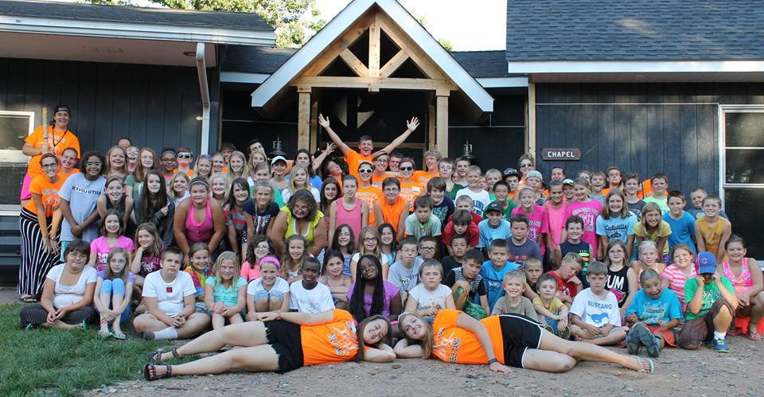
Grindstone Lake Bible Camp is seeking 100 people willing to donate $30 a month. It adds up to $360 per year from each person, but a total of $36,000 per year from all 100 contributors. That's enough to begin to tackle the lengthy list of maintenance projects needed to continue the legacy of spiritual impact that has seen thousands of significant spiritual decisions over our 83 years of ministry.
I wish to join the Mission 360 challenge!
Name:________________________________ Home Church:__________________________
Address:_____________________________________
______________________________________
Automatic donation (please complete Direct withdrawal agreement)
Monthly check
Please return this form to: Grindstone Lake Bible Camp, 13222 Grindstone Lake Rd, Sandstone, MN 55072

